ASSIGNMENT 7.5
2303A51015(SRIKARAN) BATCH-01
Task 1 (Mutable Default Argument – Function Bug)
Task: Analyze given code where a mutable default argument causes
unexpected behavior. Use AI to fix it.
# Bug: Mutable default argument
def add_item(item, items=[]):
items.append(item)
return items
print(add_item(1))
print(add_item(2))
Expected Output: Corrected function avoids shared list bug.
#before fixing
def add_item(item, items=[]):
items.append(item)
return items
print(add_item(1))
print(add_item(2))
#after fixing
def add_item(item, items=None):
if items is None:
items = []
items.append(item)
return items
print(add_item(1))
print(add_item(2))

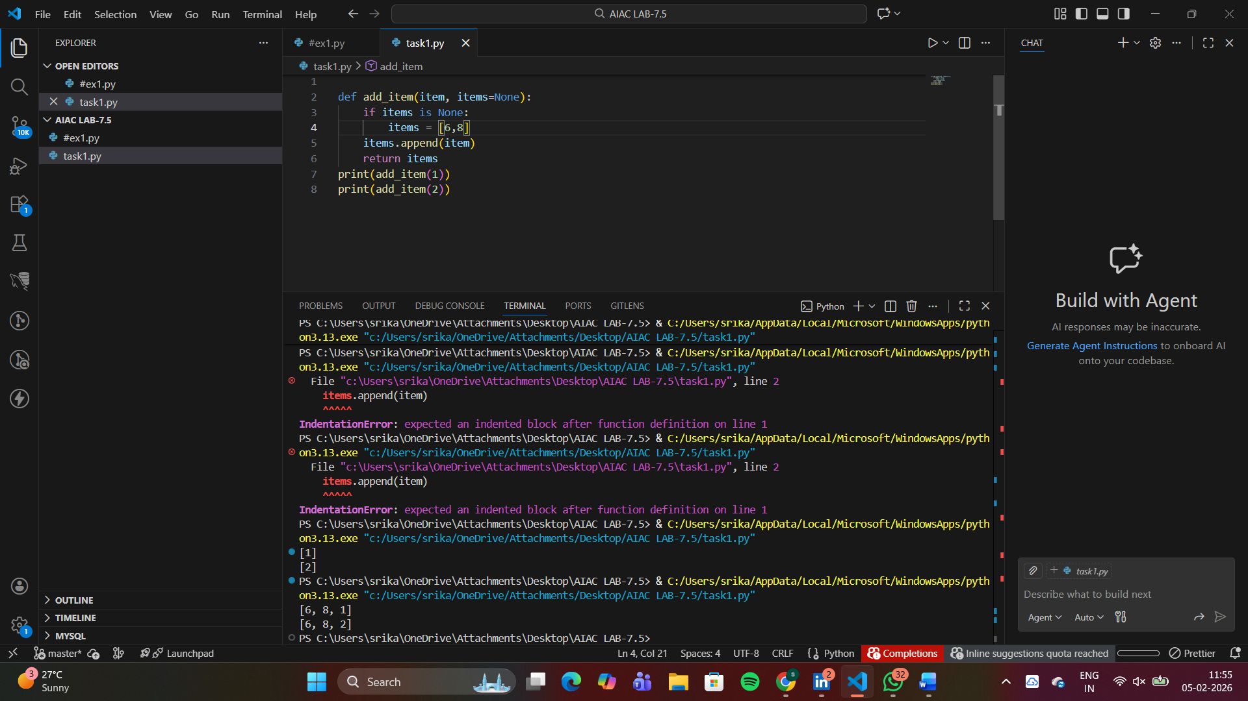
Task 2 (Floating-Point Precision Error)
Task: Analyze given code where floating-point comparison fails.
Use AI to correct with tolerance.
# Bug: Floating point precision issue
def check_sum():
return (0.1 + 0.2) == 0.3
print(check_sum())
Expected Output: Corrected function
#befor fixing
def check_sum():
return (0.1 + 0.2) == 0.3
print(check_sum())
#after fixing
import math

def check_sum():
return math.isclose(0.1 + 0.2, 0.3)

print(check_sum())
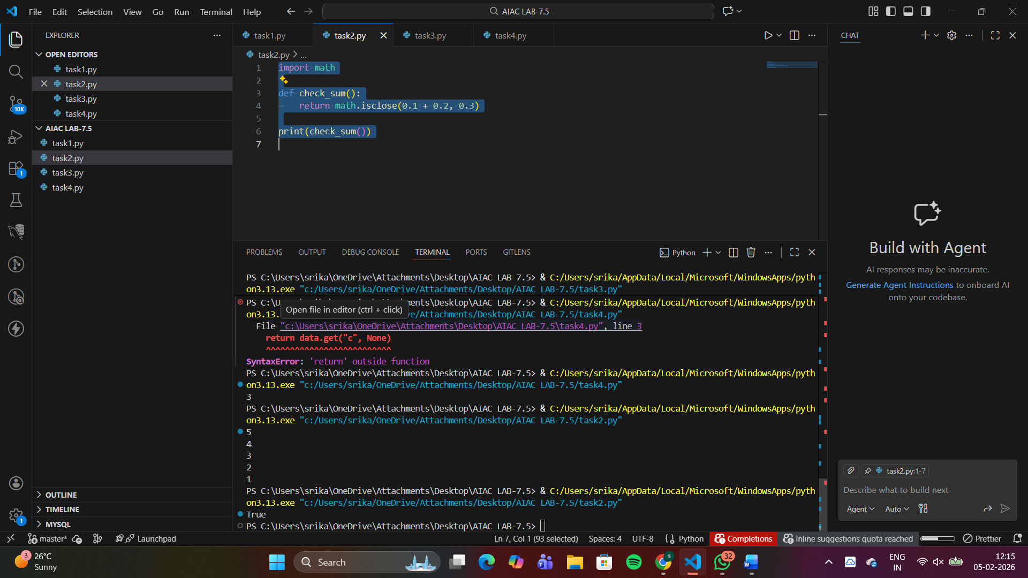

Task 3 (Recursion Error – Missing Base Case)
Task: Analyze given code where recursion runs infinitely due to
missing base case. Use AI to fix.
# Bug: No base case
def countdown(n):
print(n)
return countdown(n-1)
countdown(5)
Expected Output : Correct recursion with stopping condition.
#before fixing
def countdown(n):
print(n)
return countdown(n-1)
countdown(5)
#after fixing
def countdown(n):
if n < 0:
return
print(n)
return countdown(n-1)

countdown(5)

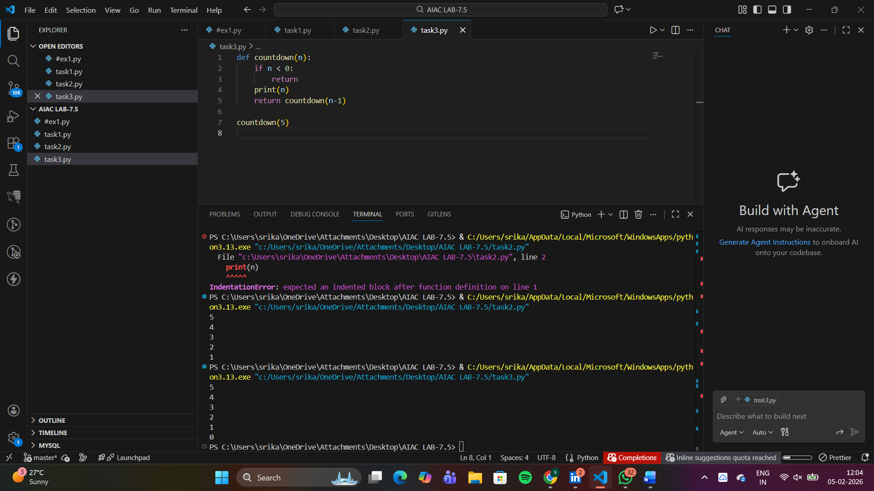
Task 4 (Dictionary Key Error)
Task: Analyze given code where a missing dictionary key causes
error. Use AI to fix it.
# Bug: Accessing non-existing key
def get_value():
data = {"a": 1, "b": 2}
return data["c"]
print(get_value())
Expected Output: Corrected with .get() or error handling.
#before fixing
def get_value():
data = {"a": 1, "b": 2}
return data["c"]
print(get_value())
#after fixing
# missing dictionary to accession non existing key
def get_value():
data = {"a": 1, "b": 2, "c": 3}
return data.get("c", None)
print(get_value())
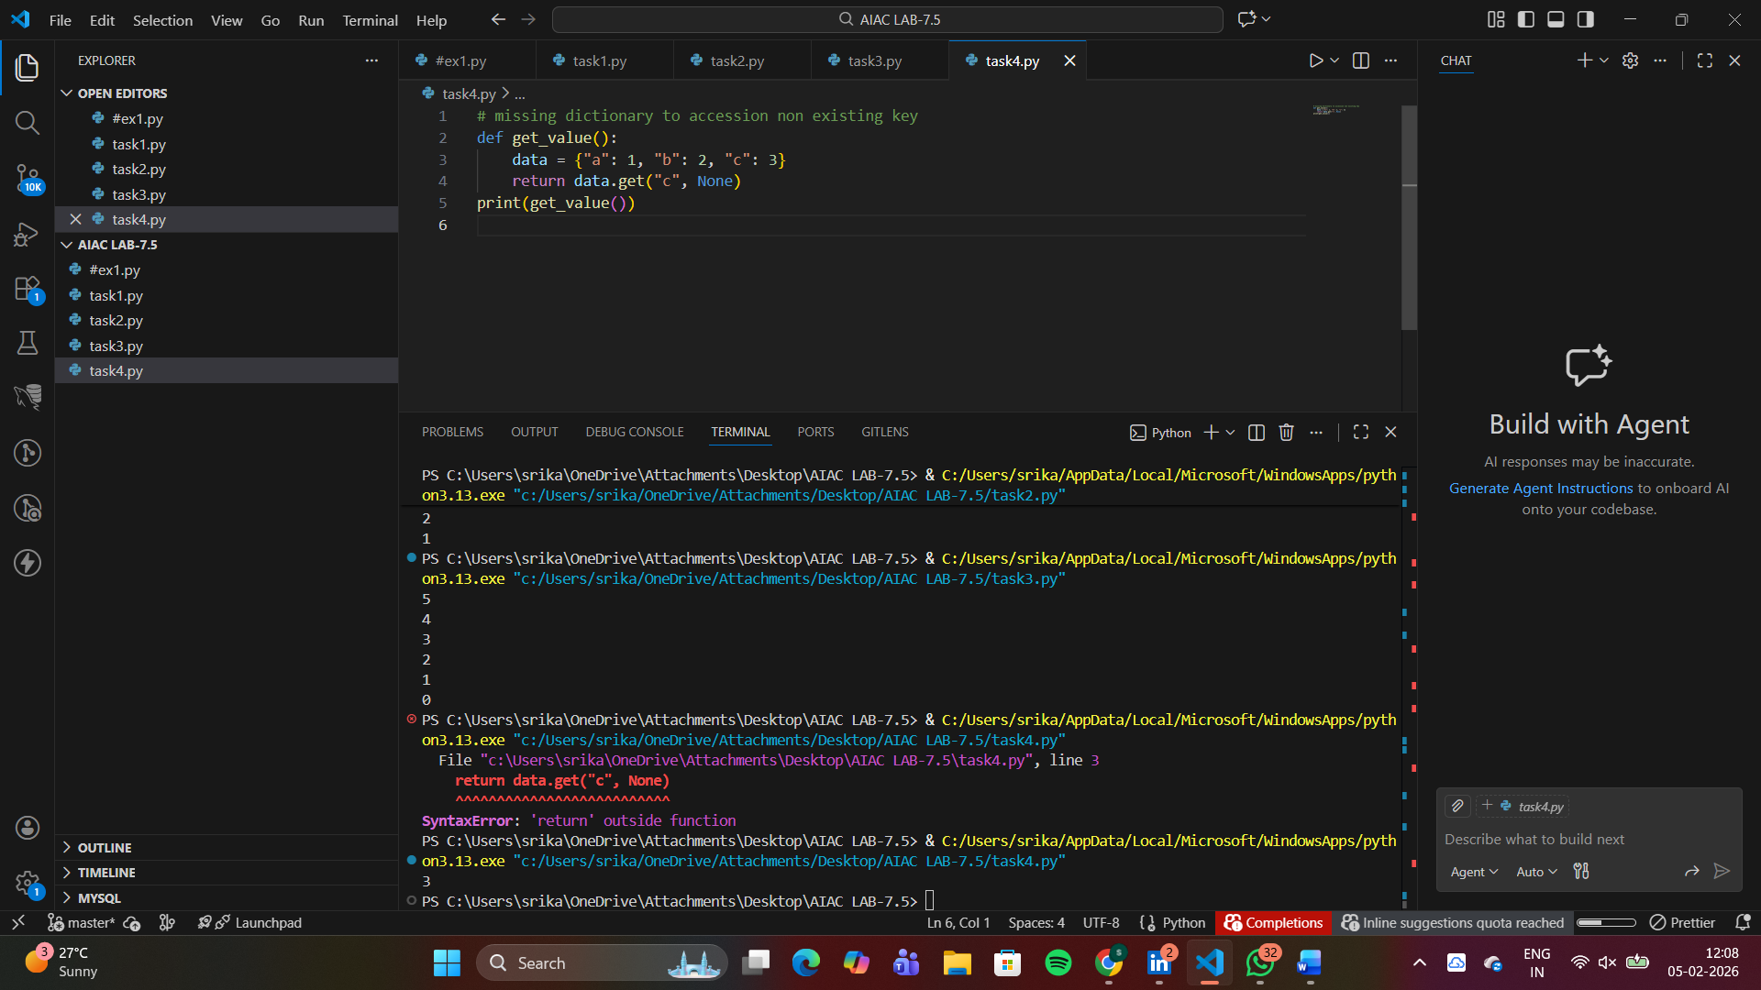
Task 5 (Infinite Loop – Wrong Condition)
Task: Analyze given code where loop never ends. Use AI to detect
and fix it.
# Bug: Infinite loop
def loop_example():
i = 0
while i < 5:
print(i)
Expected Output: Corrected loop increments i
#before fixing
def loop_example():
i = 0
while i < 5:
print(i)
#after fixing
def loop_example():
i = 0
while i < 5:
print(i)
i += 1 # Increment i to avoid infinite loop

loop_example() # Call the function to execute the loop
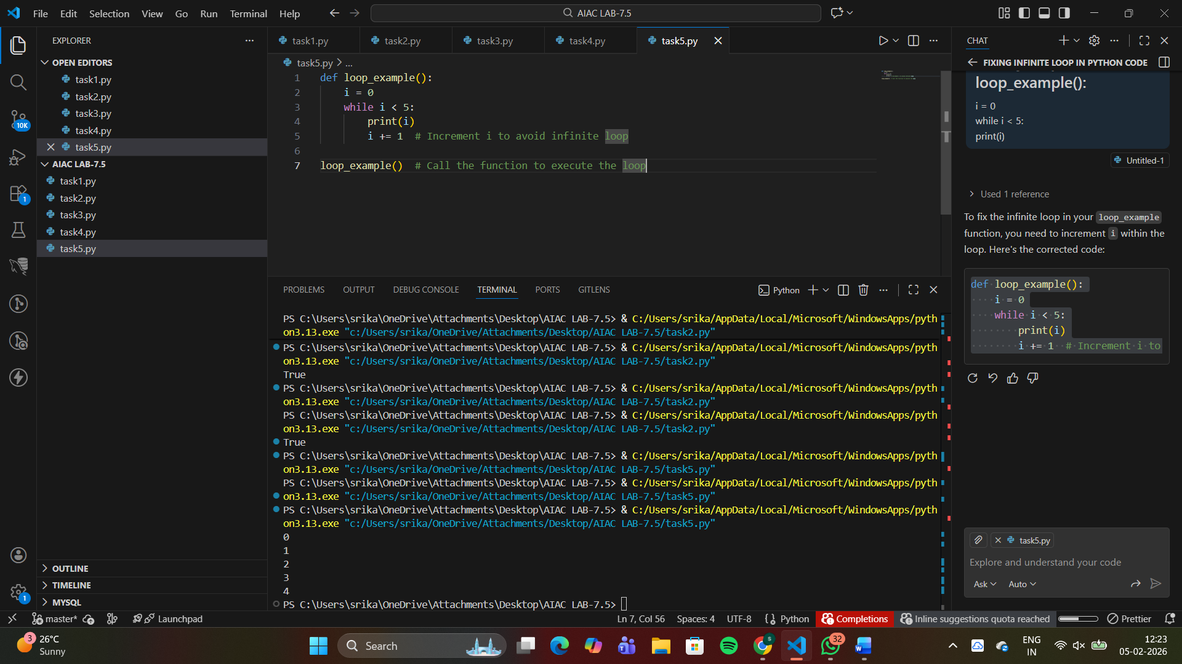
Task 6 (Unpacking Error – Wrong Variables)
Task: Analyze given code where tuple unpacking fails. Use AI to
fix it.
# Bug: Wrong unpacking
a, b = (1, 2, 3)
Expected Output: Correct unpacking or using _ for extra values.
#after fixing
# Task: Analyze given code where tuple unpacking fails. Use AI to fix it.
# Bug: Wrong unpacking - fixed by using underscore for extra values

a, b, _ = (1, 2, 3)
print(f"a = {a}, b = {b}")

